Development documentation

17.5.23

I added the navigation bar on the top of the header tag by following from this website <https://www.w3schools.com/css/tryit.asp?filename=trycss_navbar_basic_css>.

19.5.23

Because my navigation bar still has dot point. I got help from Rob to reset my css using this link which contains the code.

<https://meyerweb.com/eric/tools/css/reset/>

Additionally, I linked one stylesheet to reset.css to remove dot points from my navigation bar then added style.css and scss/main.scss stylesheets because linking to css to main.scss through @import does not work.

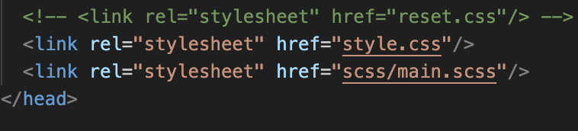

I changed the layout from grid to flex because it’s responsive to both mobile and desktop devices.

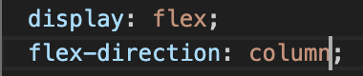

Hence, I added my images using the img tag with figcaptions as part of figure tag in html. And added align-self to figcaption in css to position below the image.

20.5.23

I created a form consists of User First Name, User Last Name, User Id, Movie Genre, Phone Number, Email, Movie Name, Rating and Movie image. Using the template from coding challenge.

I found information about how to create a rating systems for users to input data to the form. By classifying input type as radio and adding stars using span class.